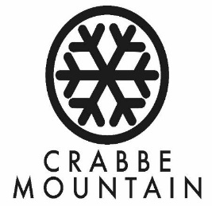
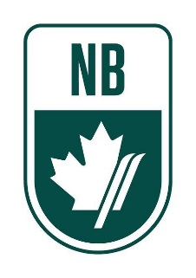
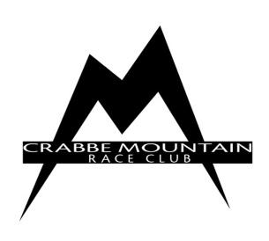

Race Notice

Ski Cross – Men and Women, U12, U14, U16+
March 24th & 25th, 2018

LOCATION/COURSE: Crabbe Mountain, New Brunswick
Ski Cross Saturday and Sunday
Terrain Park / Dave’s Dream

SANCTION: Ski NB, ACA

DATES: March 24th and 25th, 2018

ELIGIBILTY: National Card holders
Divisions: U12, U14 and U16+

RACE RULES: ACA and the spirit of the ICR
Protests are done immediately and are completed before the athlete leaves the fenced finish area. (DSQ list posted outside Race Shack).
Protest fee is $25.

ENTRY DEADLINE: Monday, March 19, 2018

ENTRY FEE: Entry fee is $110 per racer. Cheque payable to CMRC and to be submitted at Team Captains’ meeting on Friday, March 23, 2018 or E-Transfers accepted: crabbetreasurer@gmail.com (password: crabbe)

DEPOSIT: There will be a $100 bib/course pull deposit. Cheques refundable after return of all bibs and after course tear down.

ENTRIES: Send athlete entries to Kelly Storey (cmrc.race.secretary@gmail.com)
All entries must be entered on the attached Excel sheet - tab 1.

CMRC is asking each club to provide at least 5 volunteers for each race day. Free lift ticket will be provided for all volunteers. Gate Keepers will meet in the bar in the lodge at 8:15 am on Saturday, March 24 & Sunday, March 25. CMRC thanks you in advance for your help to make this event a success. Please complete the Google Document for the Volunteers - https://docs.google.com/document/d/1JmzSoBr14PCP0W8T4sTuMr2CMEmtIzoG_ppAot6k2No/edit?usp=sharing

LIFT TICKETS: Lift tickets for athletes and coaches will be available from the Race Secretary at the Crabbe Mountain Lodge Thirsty Boot Lounge at 7:50 am race day. Volunteer passes will be distributed at the CMRC Race Shack (top of the hill). **Spectators may purchase lift tickets at ticket office for 25% discount with presentation of their season pass from their home hill.

MEETING: Team Captain’s Meeting will be held Friday, March 23rd at 7:00pm in the CMRC Race Shack located at the top of the hill / chair.

EQUIPMENT: GS Skis only. Clothing – 2 piece suits (jacket and pants); No race suits.
FIS approved helmets are mandatory (sticker must be visible). Mouth guards and back protectors are recommended. No loose clothing.

AWARDS: Awards presented following Sunday’s finals in the Lodge (Thirsty Boot Lounge).

RACE COMMITTEE: Chief of Race - Shane Sutherland
Technical Delegate – Scott Carr
Chief of Course – Gerald Storey
Chief Gate Judge – Paul Mills
Chief of Timing & Calculations – Karen Sutherland
Race Secretary - Kelly Storey

ACCOMMODATONS: http://www.tourismfredericton.ca/en/index

OTHER: *Athletes’ lift tickets must be visible to lift attendants.
*Helmets are mandatory for all skiers at Crabbe Mountain.

Crabbe Mountain would like all teams to use the locker rooms beside the ticket office for changing and storage of their ski bags and gear. Once changed, teams are welcome to congregate in the main lodge area for the day.

