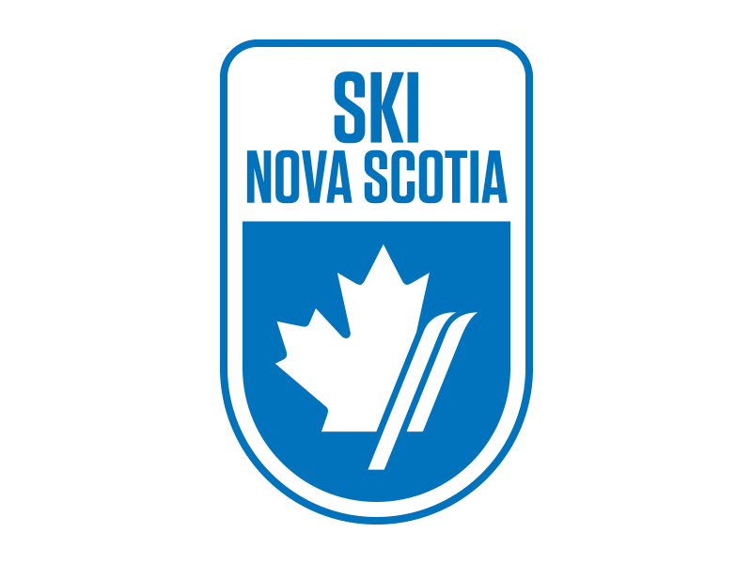
RACE NOTICE
Atlantic Cup Series Jerry Giorno Memorial Cup, Ben Eoin Ski Team
Ski Cross and Slalom U8 and up
LOCATION / COURSE – Ski Ben Eoin, Loonback, SX Track
SANCTION – Alpine Ski Nova Scotia / Alpine Canada Alpin
DATES – Saturday March 3rd, 2018 and Sunday March 4th, 2018
ELIGIBILITY - U8 and up
RACING RULES – ACA rules will govern. All protests to be submitted in writing within 15 minutes of DSQ. Protest fee is $50.
ENTRY DEADLINE – Tuesday February 27th, 2018
ENTRY FEE – Entry fee: $110 includes two-day lift passes for each racer and two coach lift tickets per team. Additional lift tickets are available at a cost of $ 25 per day. Cheques are payable to Ben Eoin Ski Team and are to be submitted at the Coach’s meeting on Friday, March 3rd, 2018. Or via e-transfer to redrosevp@hotmail.com with BEST2018 as the password. *One cheque per team please.
ENTRIES – Send all entries via email to Nancy Nippard, Chief of Administration, at beneoinskiteam@gmail.com. Please list athlete’s full name, National #, gender, DOB, category and Club. Start lists will be generated on Friday night and circulated with the bibs Saturday morning. Bibs will be available in the boardroom of the chalet on Saturday morning.
DEPOSIT – There will be a $100 bib/course pull deposit per team. Cheques to be submitted at the Coach’s meeting and are refundable after return of all bibs and after course tear down.
VOLUNTEERS – Ben Eoin Ski Team is asking each club to provide 4 Gate Keepers plus experienced Course Crew. Gate keepers will meet in the main chalet at 8:00am
RACE COMMITTEE – Co-Chiefs of Race – Bettina Callary and Kevin Elworthy. Technical Director (SX and SL) – Blake Johnston. Chief of Course – Steve Giorno. Chief of Gates - Blair Power. Chief of Timing – Bob Pelley. Race Secretary – Lynn Murphy
COACH’S MEETING – Friday, March 3rd, 2018 at 7pm at Ski Ben Eoin boardroom upper level main chalet. It is mandatory for each team to have a coach, representative present at this meeting.
LIFT TICKETS – $25.00
OFFICIAL BOARD - DSQs will be posted at the bottom of the stairs in the main chalet.
EQUIPMENT – Helmets are mandatory. All athletes must wear alpine Ski racing helmets. Race suits permitted for Slalom ONLY.
SCHEDULE –
Saturday – Ski Cross. Training Runs 9:30am, Qualifying 11:15 am, Heats begin 1:30pm, Awards to follow
Sunday – SL , Training runs 7:15 am Course inspection 8:30am, First run 9:15am Re-set upon completion (details at coaches meeting)
AWARDS – Ski Cross medals will be presented on the deck of the Ski Ben Eoin main chalet after Saturday’s races. Slalom medals will be presented on the deck of Ski Ben Eoin main chalet after Sunday’s races.
ACCOMODATIONS -
Holiday Inn Express Sydney - 902-562-7500
Hampton Inn Sydney - 902-564-6555
Birches of Ben Eoin 902- 564-5189 or 902- 564- 6324

