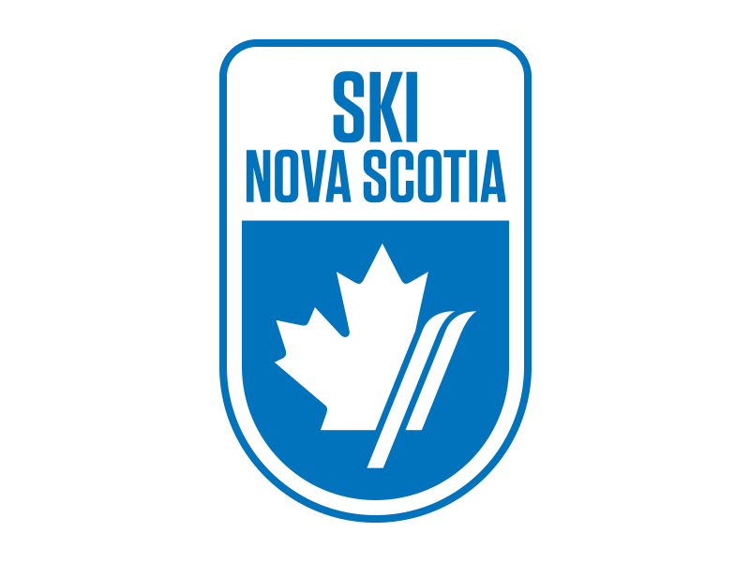
SX CAMP NOTICE
Ben Eoin Ski Team
Thursday and Friday March 1st and 2nd, 2018
LOCATION / COURSE – Ski Ben Eoin, SX track
SANCTION – Alpine Ski Nova Scotia / Alpine Canada Alpin
DATES – Thursday, March 1st and Friday, March 2nd
TIMES – Thursday - Coaches meeting 12:30 boardroom chalet, On Snow 1-4pm, Friday 10:00 -4 pm (Coaches doing the SX on snow module 8:45am)
ELIGIBILITY - Alpine Canada Card holders, Divisions: U8 and up
ENTRY DEADLINE – Tuesday February 27th, 2018
ENTRY FEE – Entry fee: $110 includes two-day lift passes for each racer and two coach lift tickets per team. Additional lift tickets are available at a cost of $ 25 per day. Cheques are payable to Ben Eoin Ski Team and are to be submitted at the Coach’s meeting or via e-transfer to redrosevp@hotmail.com with BEST2018 as the password. *One cheque per team please.
SX Camp will be under the direction of Kevin Elworthy ACA SX facilitator. Additionally an on snow Coaching module for coaches will take place on March 2nd, beginning at 9:00 am.. To register for this module go to canskicoach.org. This module allows coaches to work with athletes in an SX program. For any additional information please contact Kevin Elworthy at kevinelworthy@gmail.com or 1-902-217-3452.
ENTRIES – Send all entries via email to Nancy Nippard, Chief of Administration, at beneoinskiteam@gmail.com. Please list athlete’s full name, National #, gender, DOB, category and Club.
EQUIPMENT – Helmets are mandatory. All athletes must wear alpine Ski racing helmets. No Race suits permitted
ACCOMODATIONS – Holiday Inn Express Sydney - 902-562-7500, Hampton Inn Sydney - 902-564-6555, Birches of Ben Eoin 902- 564-5189 or 902- 564- 6324

