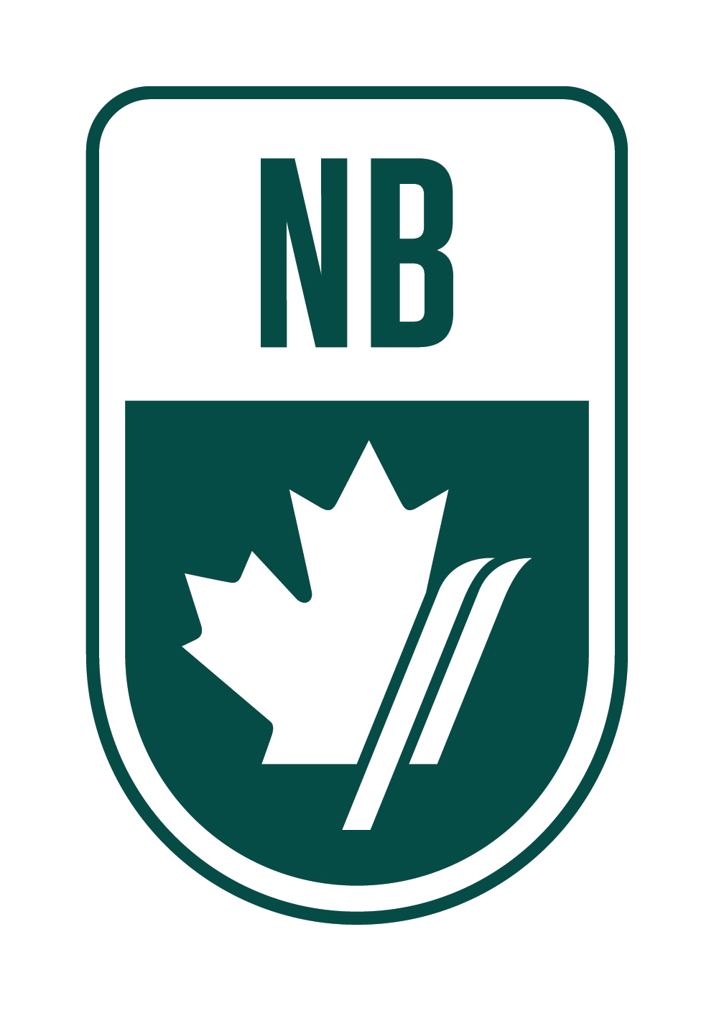
Ski Cross Camp
March 22 and 23, 2018
Crabbe Mountain, Lower Hainesville NB
U12-U99

Get ready for some Ski Cross!
Get some pre-race training at Crabbe Mountain with our Ski Cross Camp from March 22- March 23 to get ready for the SX race that takes place March 24 and 25,2018.
Two days of training at Crabbe Mountain on the SX track which is professionally constructed and maintained.
COST: | $55 per day of $110 for 2 days
WHAT IS INCLUDED: | Lift Tickets and One Athlete Dinner. Access to and training on a professionally constructed green SX track
DAILY SCHEDULE:
9:15 am | Group Warm-up
9:30 am | Lift Access for the day, Training
12-1 pm | Lunch
1-3 pm | Training
Camp will consist of a progression where the athletes and coaches will slowly work from inspecting the track to running sections to individual athletes skiing the track to eventually skiing 4 up.
To Register for this Camp, contact Ski NB Technical Director, Michele Leger at michele@skinb.ca

